**Operational Amplifier Applications-Inverting Summing Amplifier and**

**Difference Amplifier**

**LAB # 08**

** Fall 2019**

**Fall 2021**

**CSE202L Circuit system-II**

Submitted by: **Ashfaq Ahmad**

Registration No. : **19PWCSE1795**

Class Section: **B**

“On my honor, as student of University of Engineering and Technology, I have neither givennor received unauthorized assistance on this academic work.”

Student Signature: ______________

Submitted to:

**Engr. Faiz ullah**

February 3, 2021

**Department of Computer Systems Engineering**

**University of Engineering and Technology, Peshawar**

**OBJECTIVES:**

To demonstrate the use of Operational Amplifier for performing mathematical operations of summation and difference.

**EQUIPMENT:**

1. DC Power Supply
2. Oscilloscope
3. Function Generator

**Components**

1. LM 741 Op-amp
2. 47kΩ
3. 100kΩ

**Part A**

**Inverting Summing Amplifier**

**Theory Overview**

Figure 1 shows an example of how an operational amplifier is connected to perform voltage summation. It is used for summing voltages. It is also called voltage Adder. In this figure, an ac and a dc voltage are summed. We can also add AC voltages or DC voltages separately. In general,

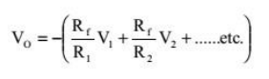

**Circuit diagram:**

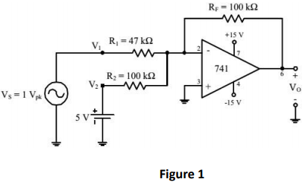

**Procedure**

1. Theoretical values,

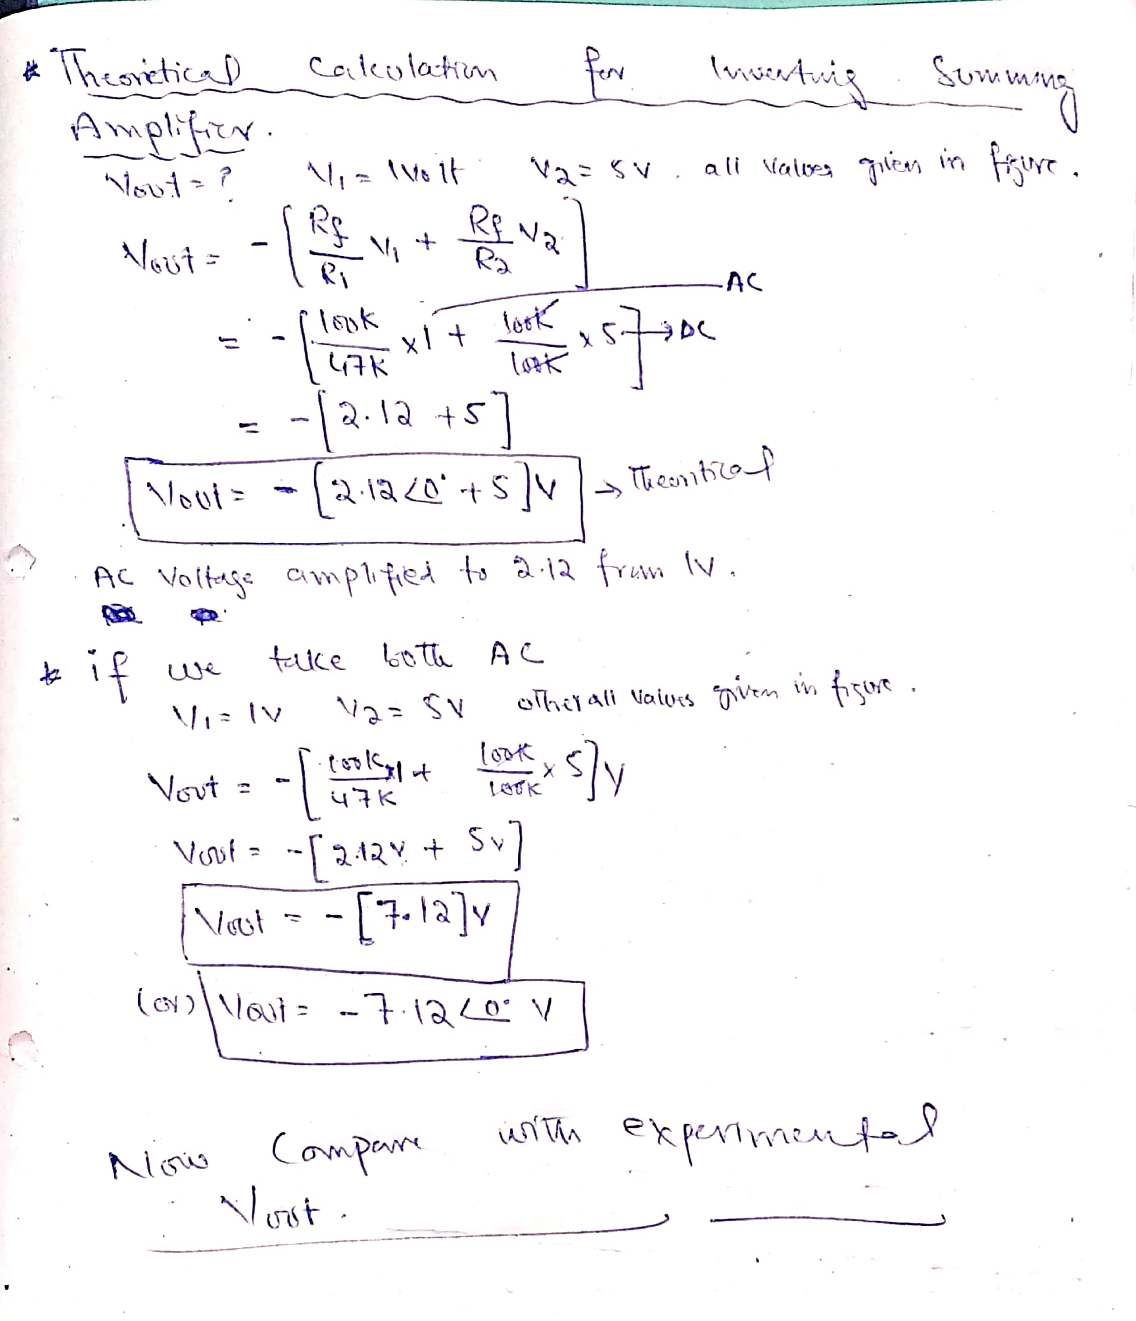

1. To demonstrate the use of an operational amplifier as a summing amplifier, construct the circuit as shown below.

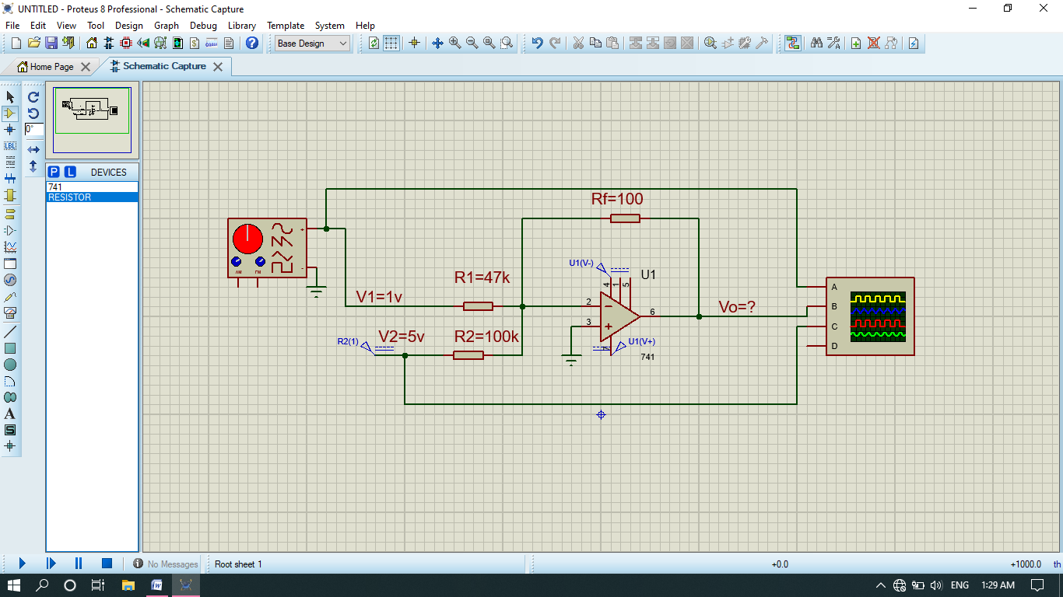

1. All at ground state.

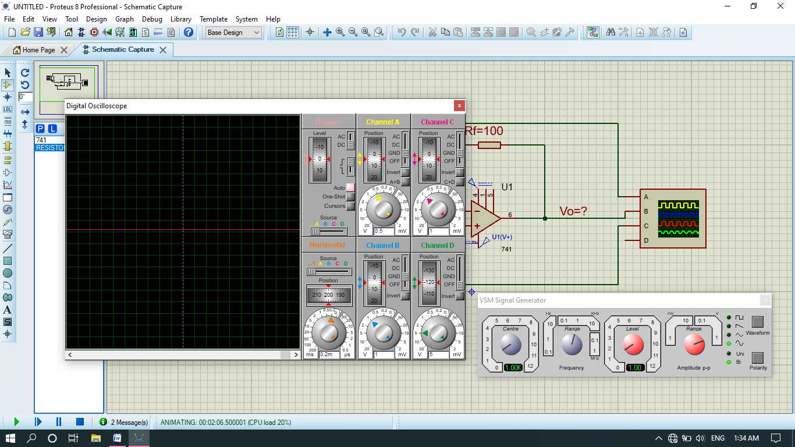

1. Now output of V1, V2 and vout .

V1= 1volt

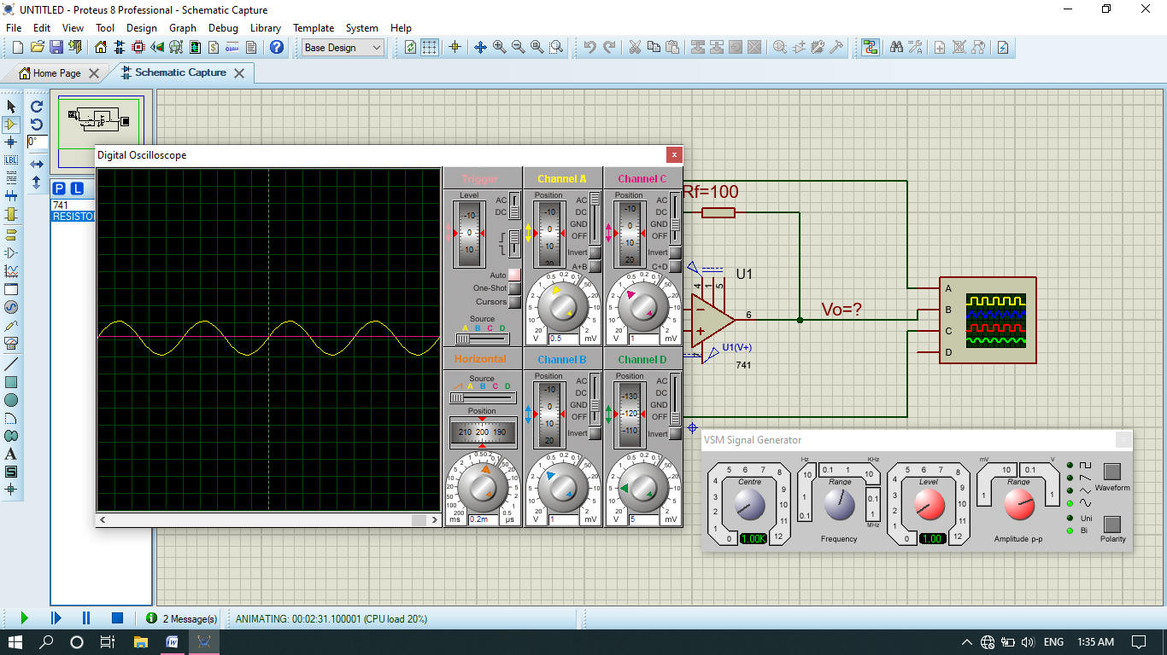

V2=5v Dc (graph of DC move 5 division upward and division scale reading is 1 so 5*1=5v)

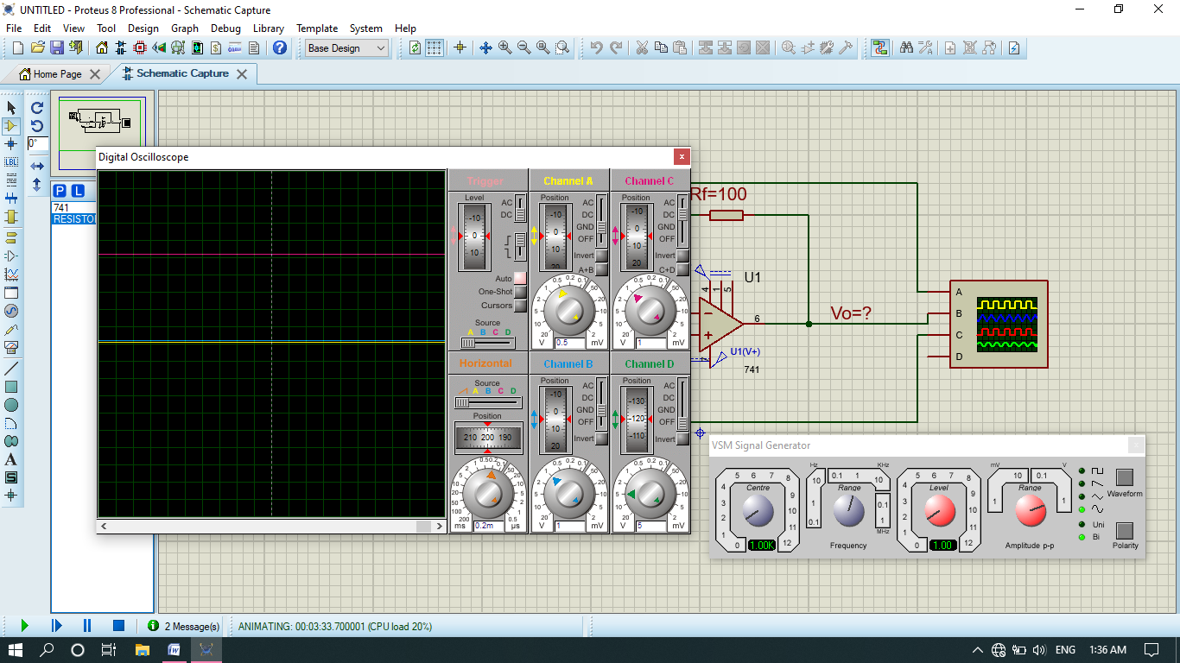

Vout=(2AC+5DC)V 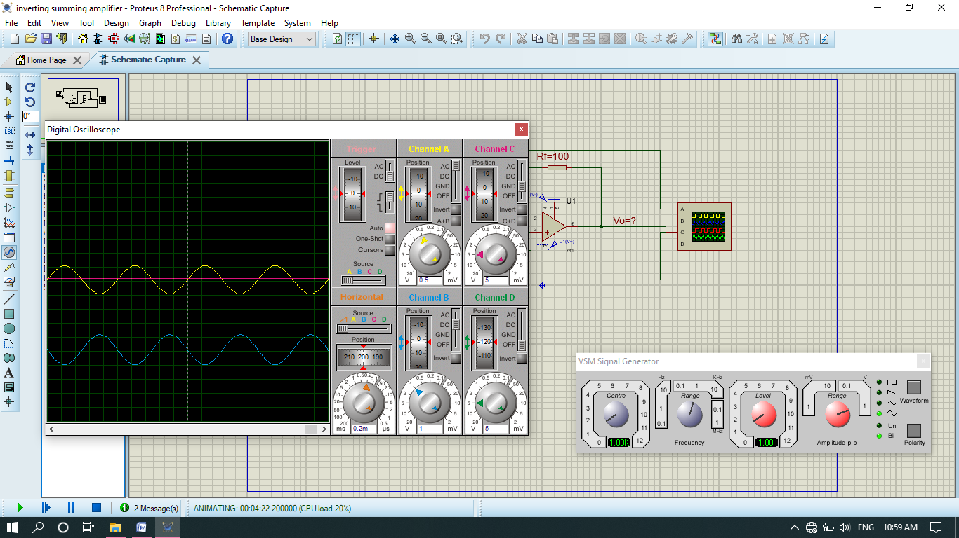

Note: the graph of vout move downward about 5 divisions its mean that DC voltage have also been added. Total divisions at output are 7. Two of them represent Ac voltage and 5 of them represent Dc voltages. The downward motion is due to inverting amplifier I,e DC voltage is given on inverting side.

* If we set the output channel of amplifier only at AC State then Dc voltage will not be added. It will amplify the input Ac voltage as shown below.

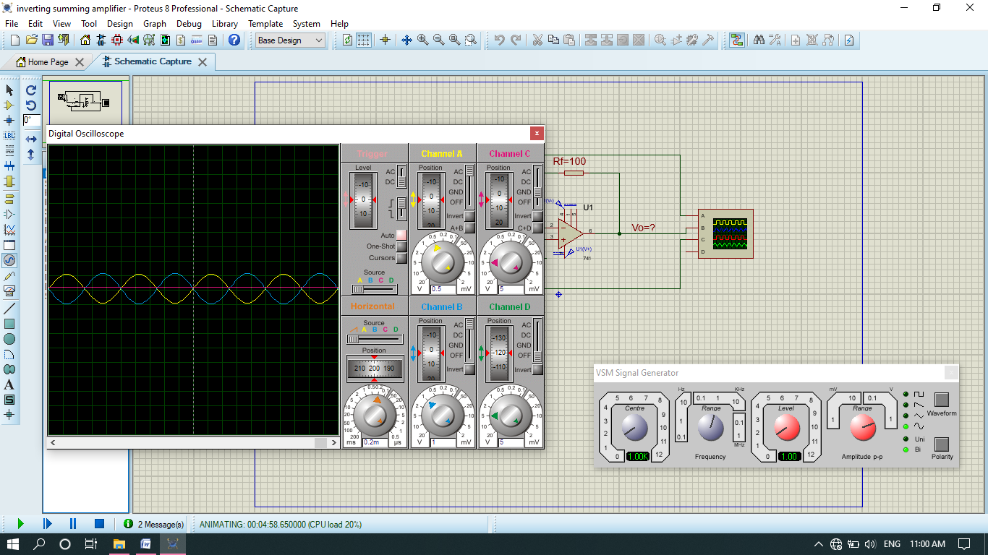

The input voltage amplified from 1v to 2v.the phase angle is 180 degree because of inverting amplifier.

1. Now if we take both voltages are AC or Dc I,e

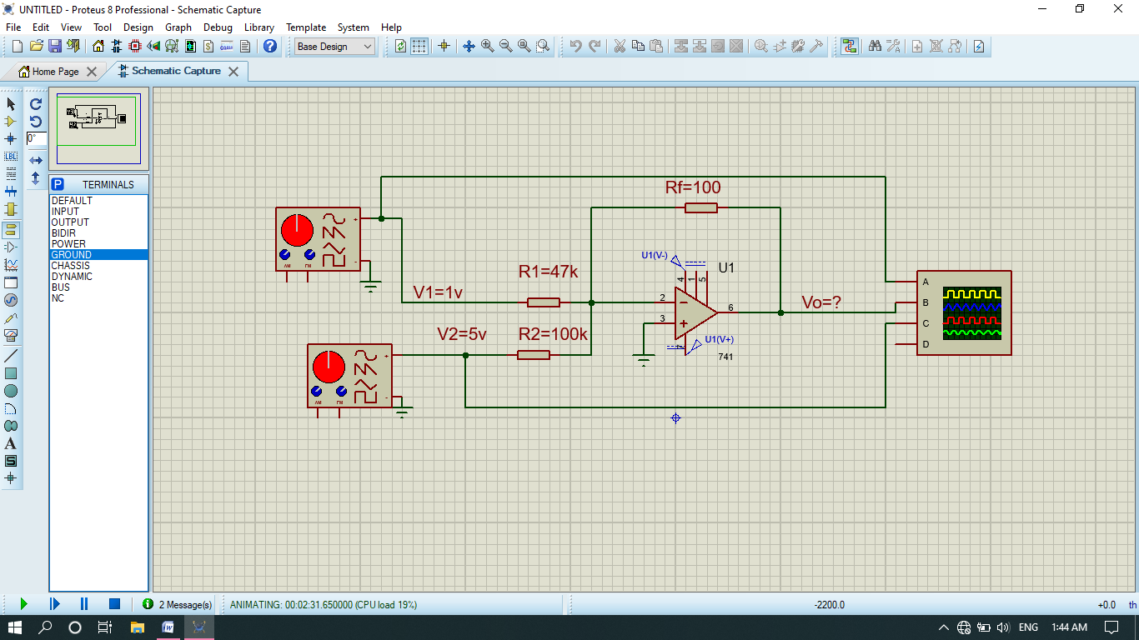

1. All at ground state.

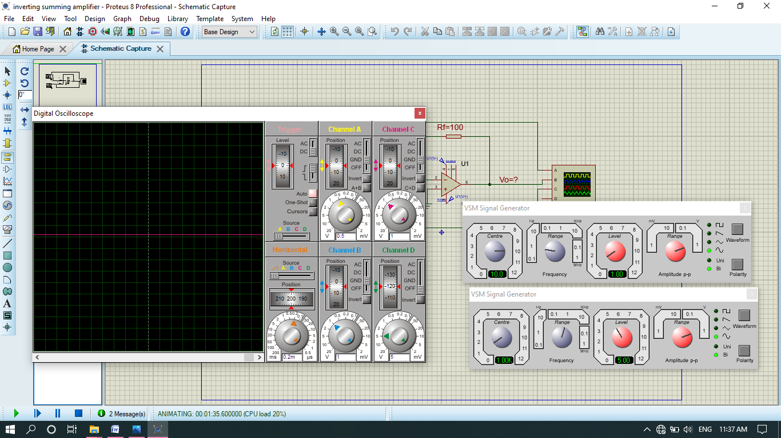

1. The inputs of V1(yellow line) and V2 (pink line) is,

V1=1v and v2=5v

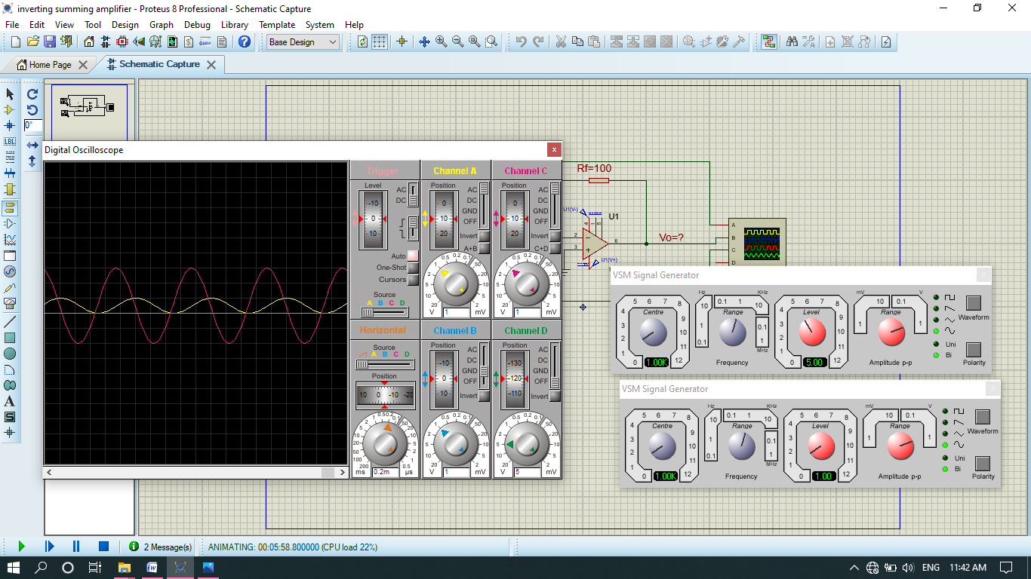

1. The output vout of amplifier represented by blue line is,

Vout = 6.2*1=6.2V

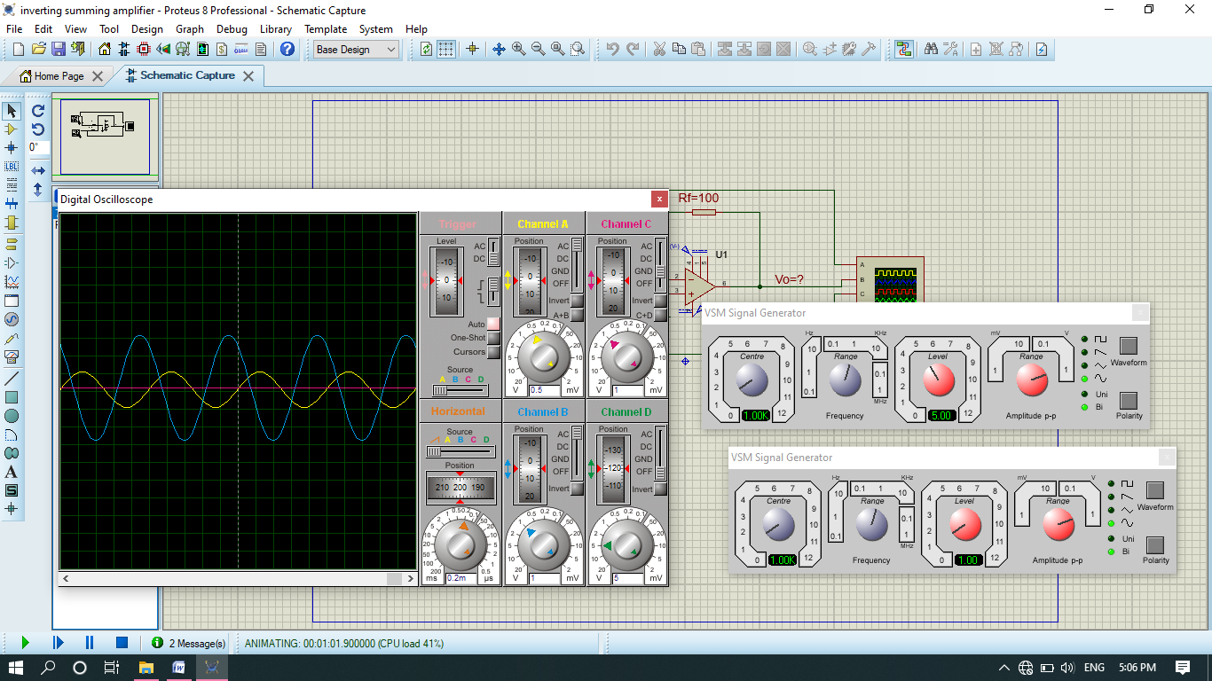

* Vout is the sum of v1 and v2.
* Similarly we can do it for both DC.

**Part B**

**Difference Amplifier**

**Theory Overview**

A difference amplifier has two inputs and one output voltage is proportional to the voltage difference of the input voltages. In fact, the (open-loop) Op-Amp itself is a difference amplifier, except that the gain is ideally infinity. Here we want a difference amplifier with finite gain*. In case of difference Amplifier we subtract voltage of inverting amplifier from voltage of non-inverting amplifier.* One such circuit using a single Op Amp is shown in Figure 4. It can be shown that the gain of the difference amplifier can be calculated using the following:

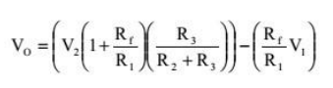

**Circuit Diagram:**

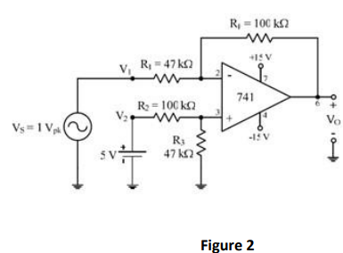

This equation can be simplified by making R3= Rf= R1= R2, yielding a simple differential amplifier with unity gain: **V0=V2-V1**

**Procedure**

1. **Theoretical calculation.**

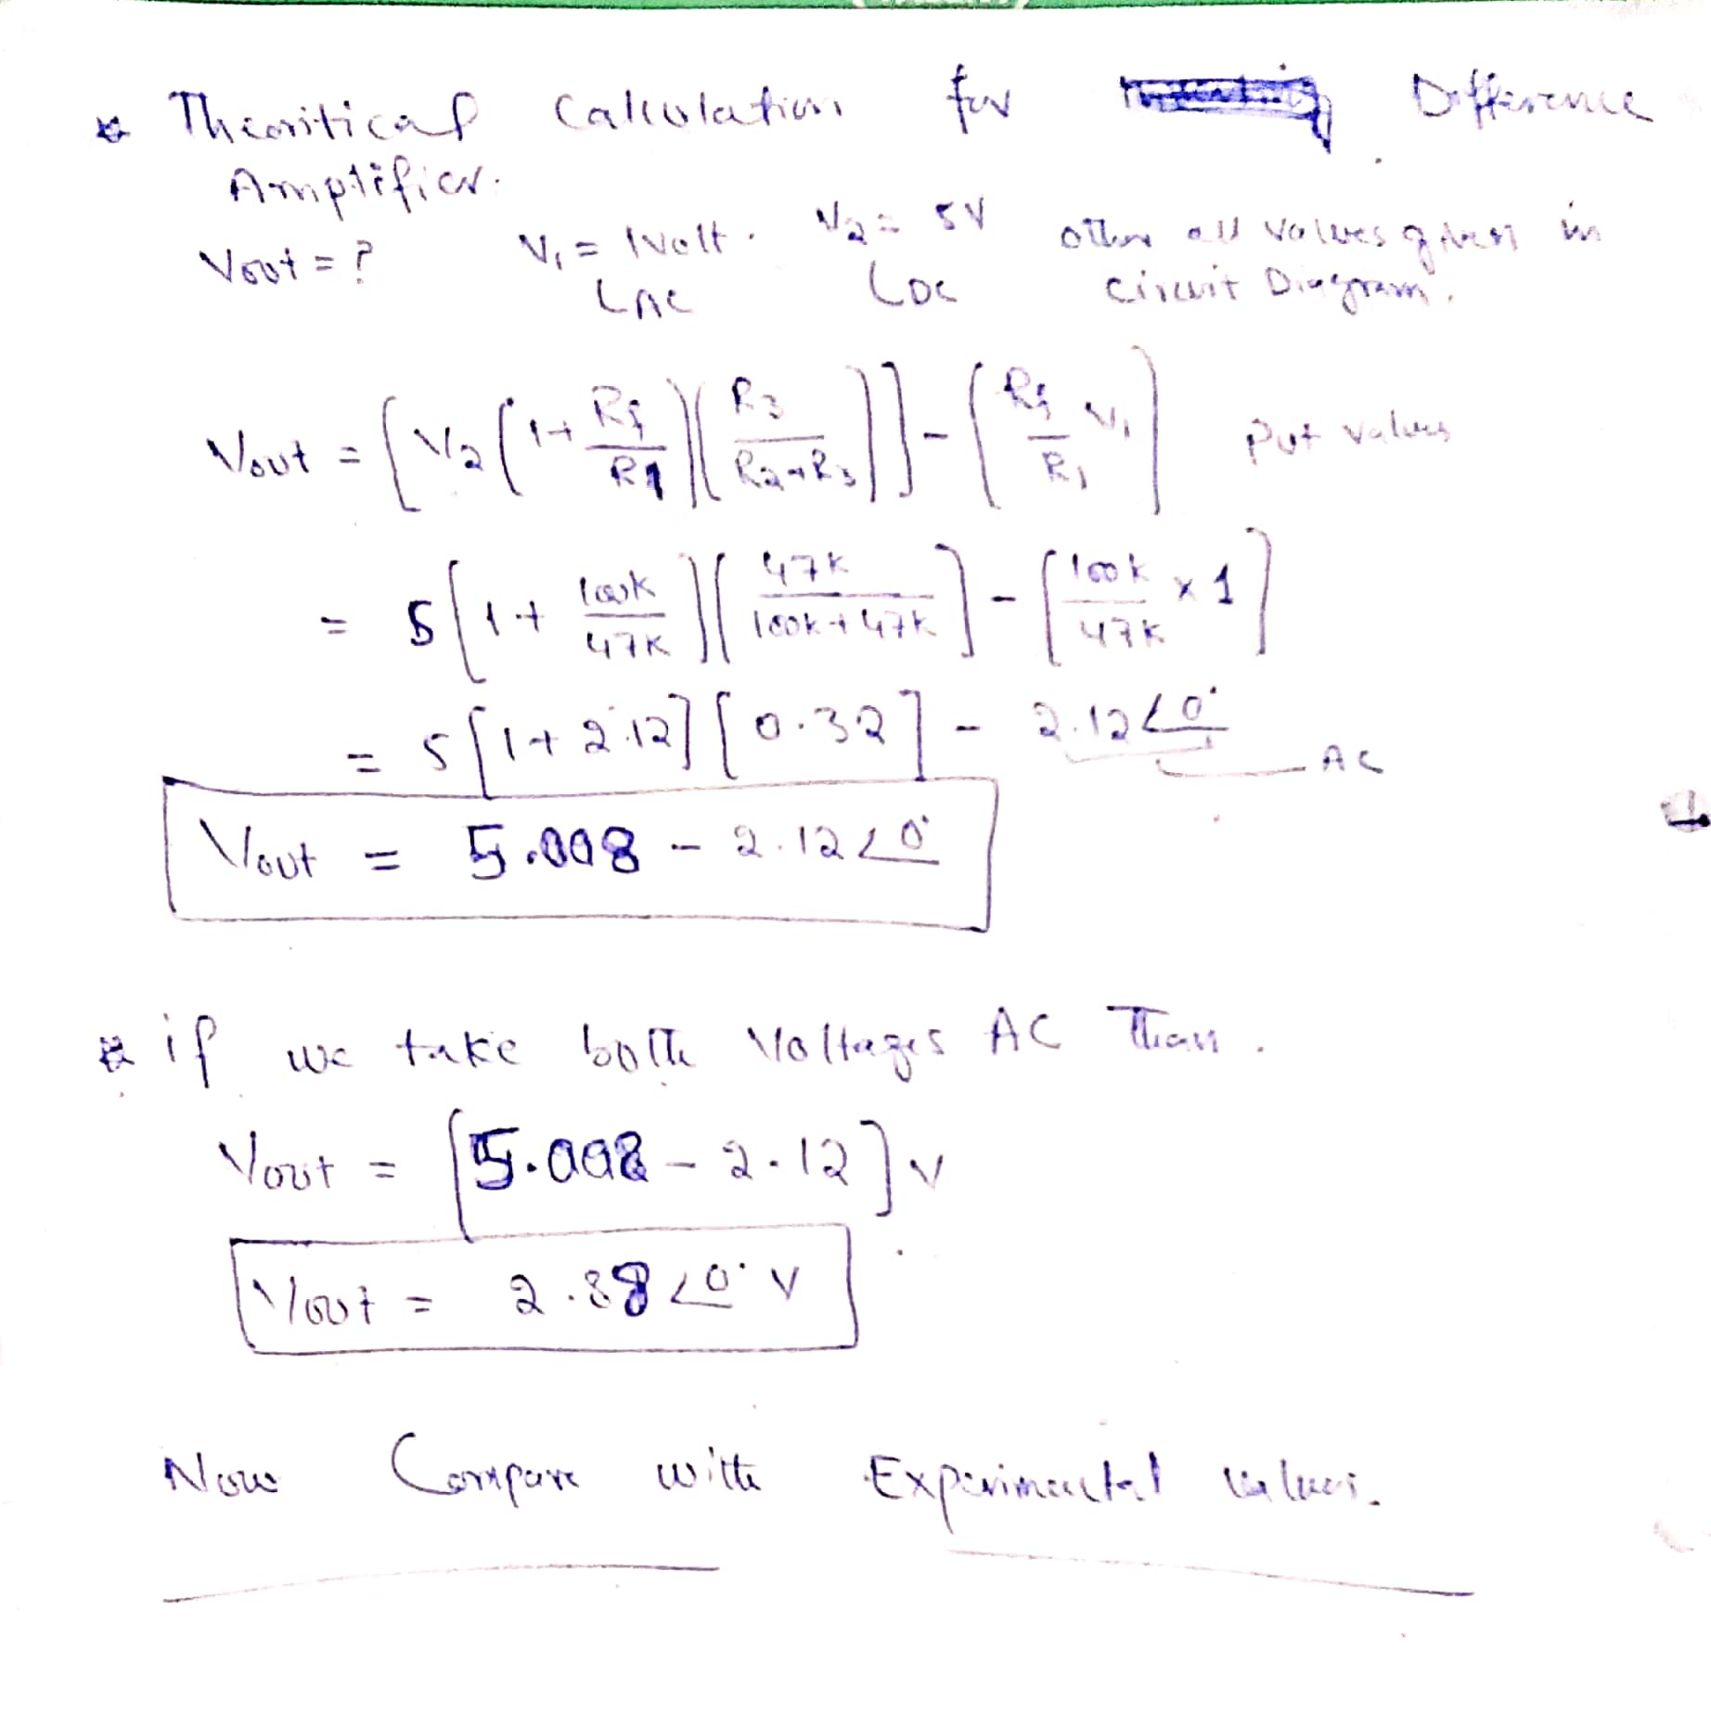

1. To investigate the use of an operational amplifier in a difference amplifier configuration, construct the circuit as shown below.

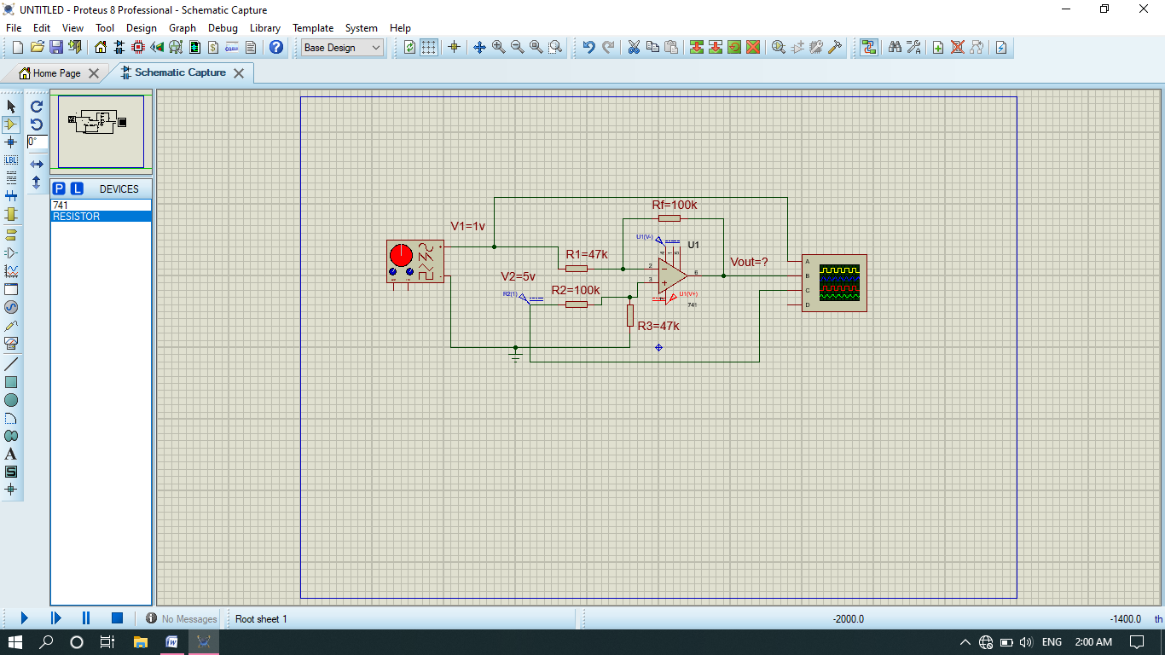

1. All at ground state.

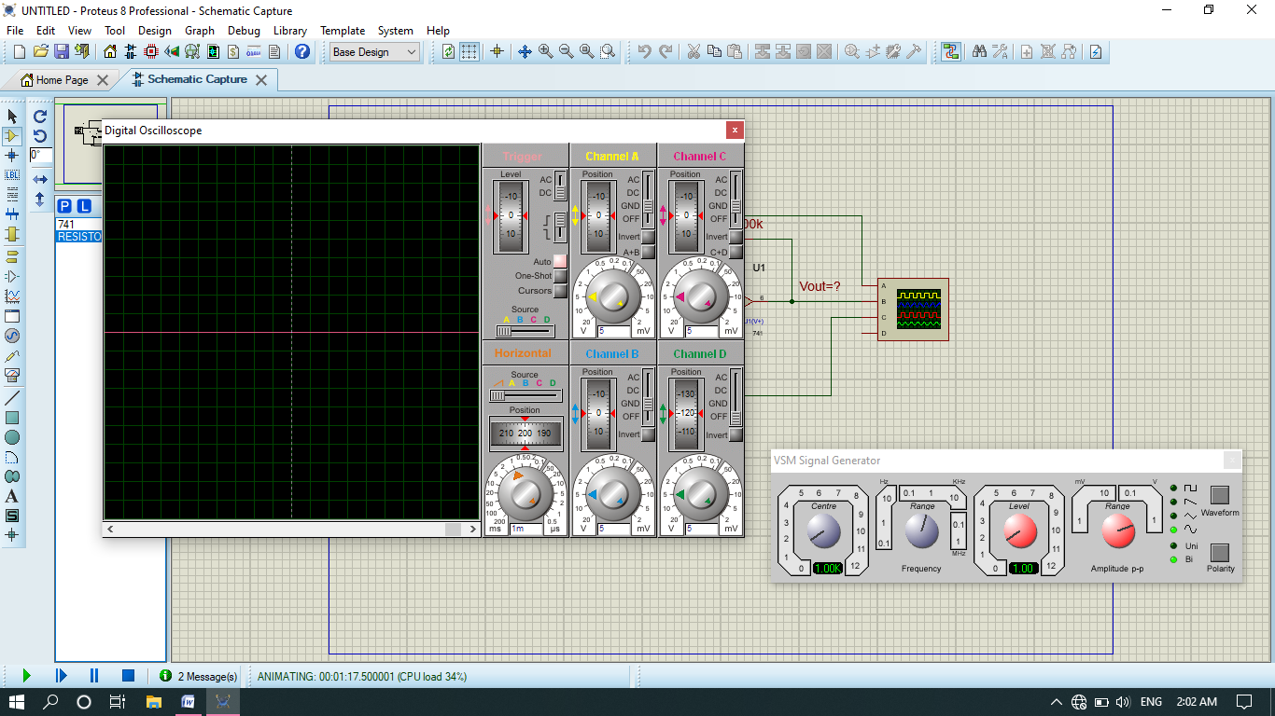

1. Now output of V1, V2 and vout .

V1= 1volt

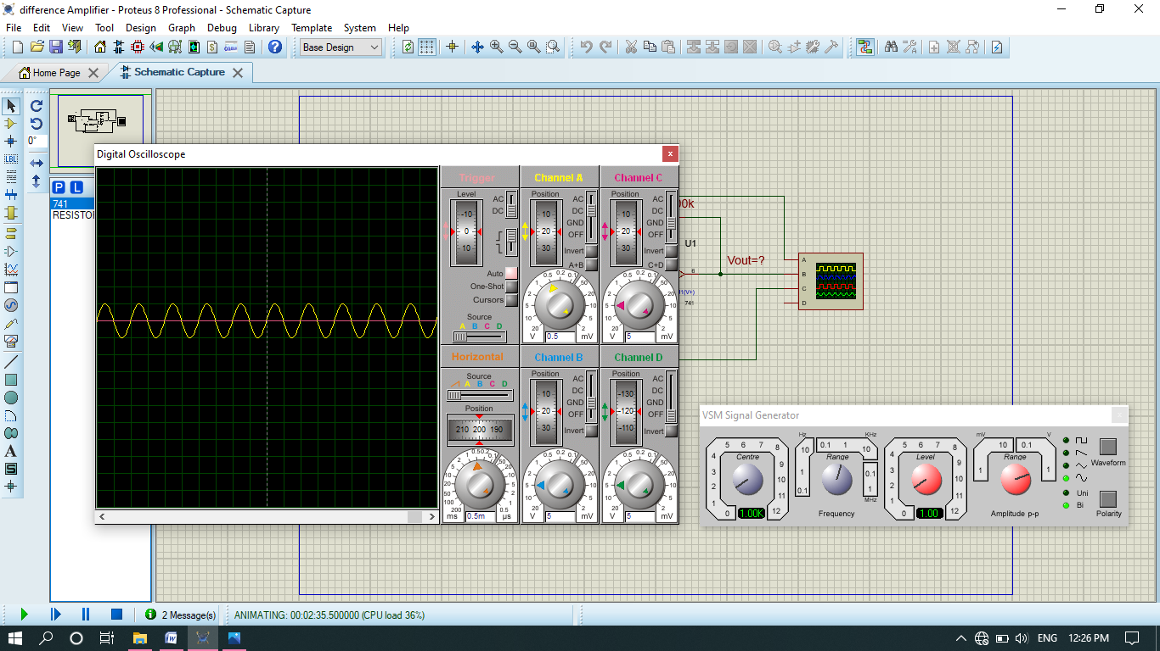

V2=5v Dc (graph of DC move 1 division upward and division scale reading is 5 so 5*1=5v)

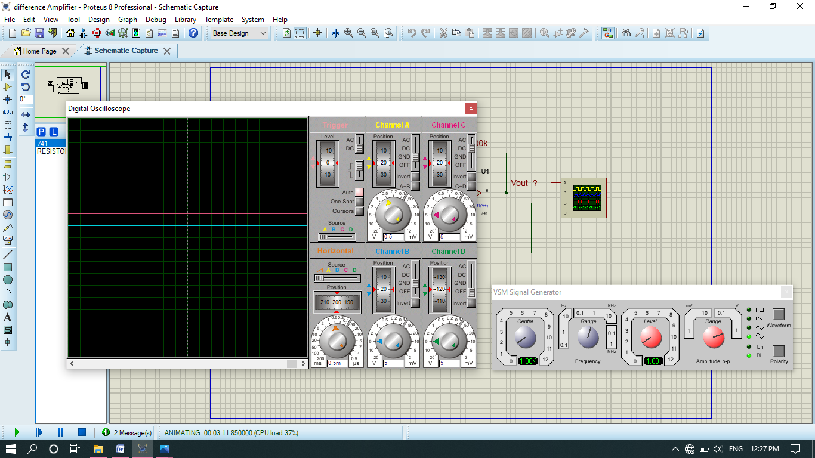

Vout=(5Dc-1.5Ac)V

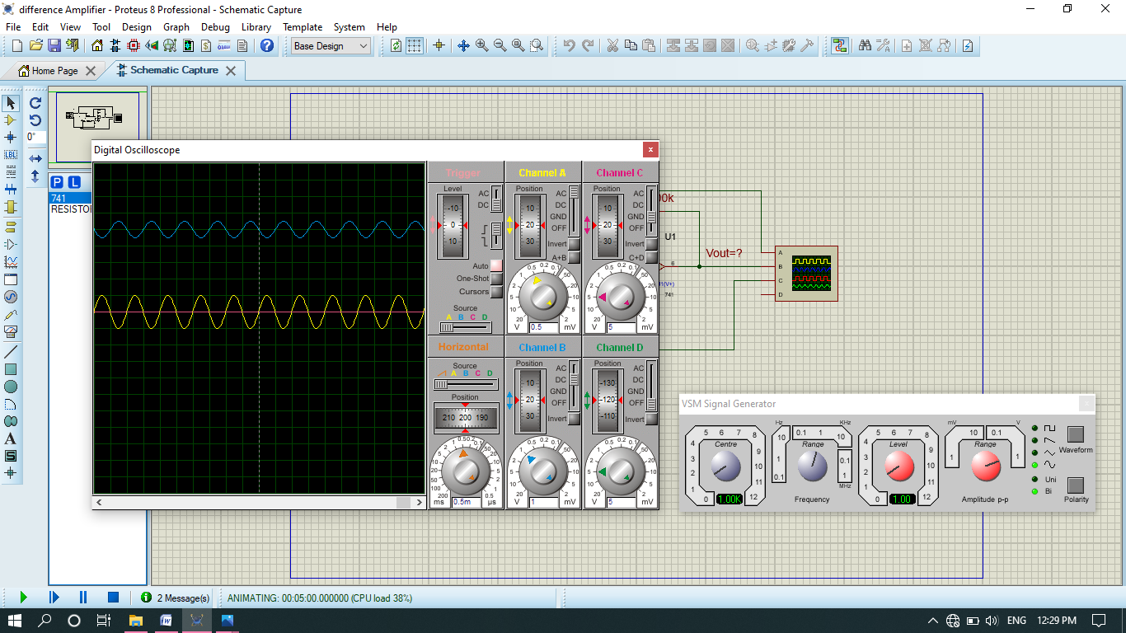

Note: the graph of vout move upward about 5 divisions its mean that AC voltage is subtracted from DC voltage. Total divisions at output are 6.5. 1.5 of them represents Ac voltage and 5 of them represent Dc voltages. The upward motion is due to non-inverting amplifier I,e Dc voltage is given on non-inverting side.

* If we set the output channel of amplifier only at AC State then Dc voltage will not be added. It will only amplify the input Ac voltage as shown below.

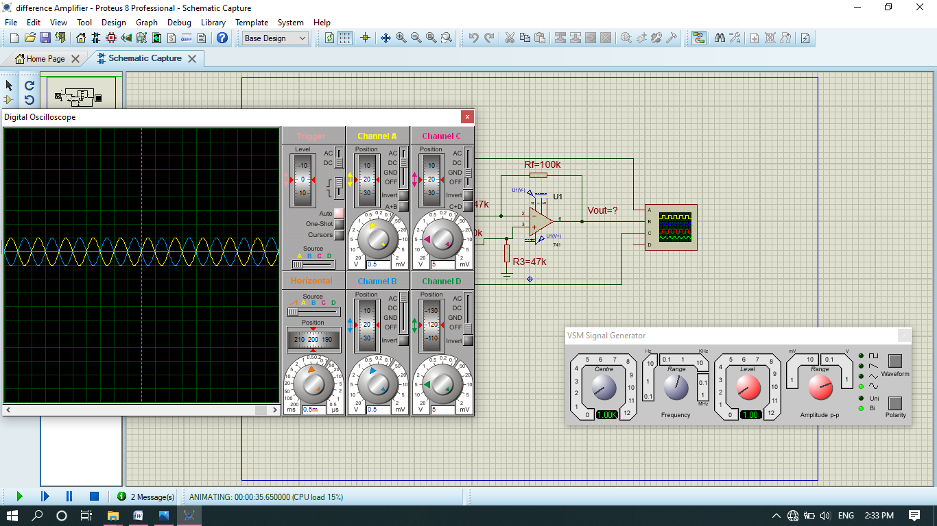

The input voltage amplified from 1v to 1.5v.the phase angle is 180 degree because of inverting amplifier.

1. Now if we take both voltages are AC or Dc I,e

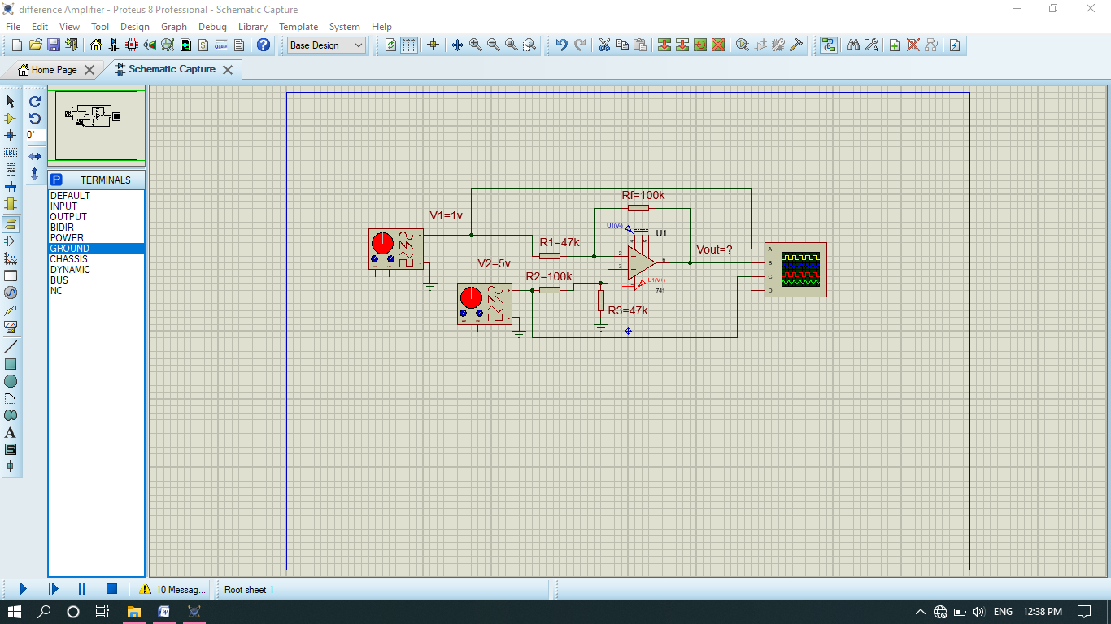

1. All at ground state.

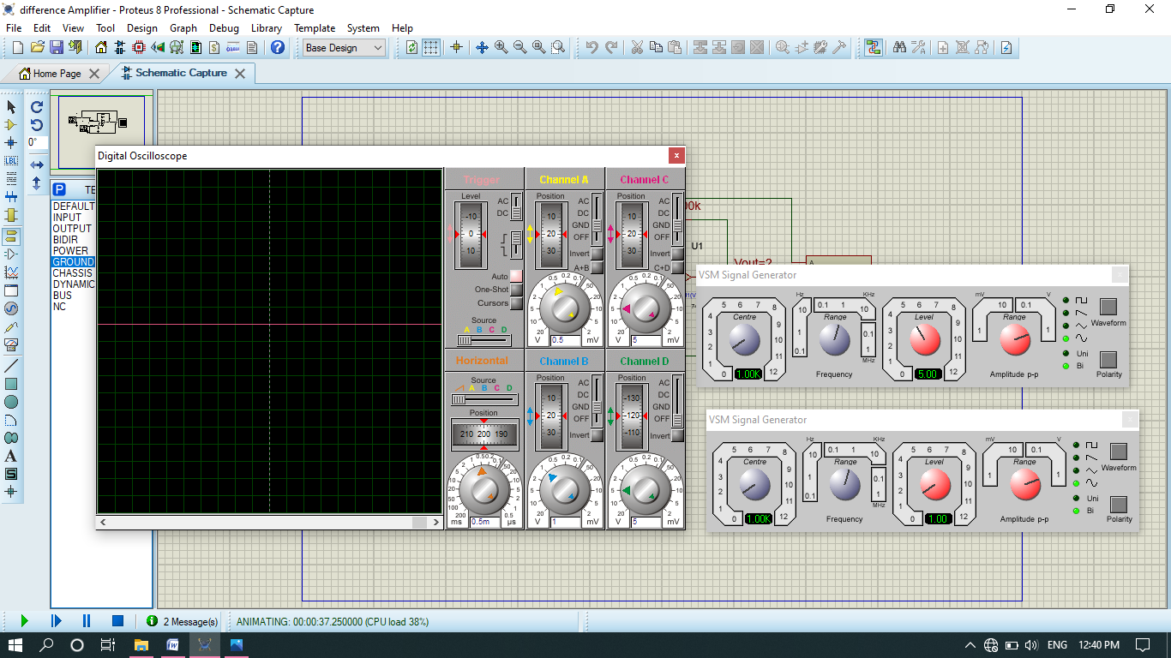

1. The inputs of V1(yellow line) and V2 (pink line) is,

V1=1v and v2=5v

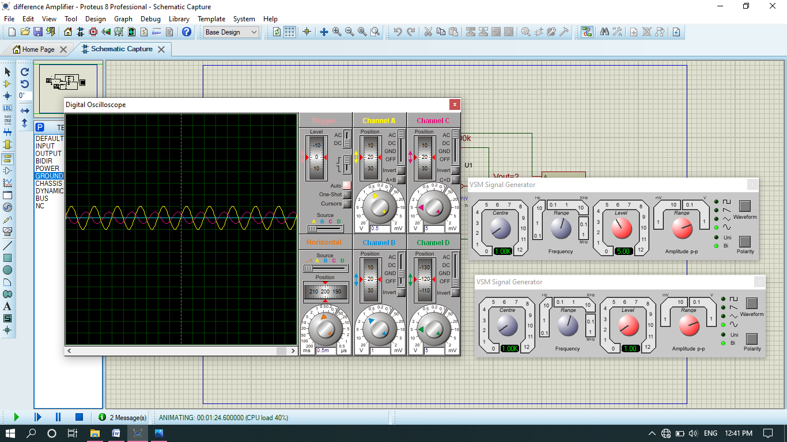

1. The output vout of amplifier represented by blue line is, Vout = 6*1=6V.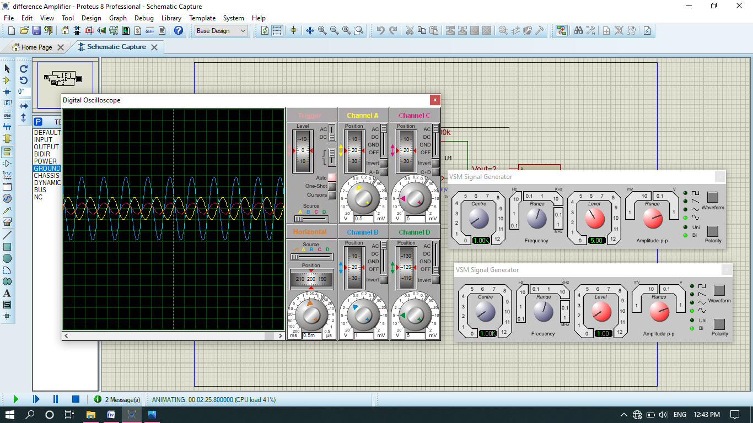

* Vout is the difference of v2 from v1.
* Similarly we can do it for both DC.

***THE END***

Few errors:

* In case of difference amplifier Ac-Ac case experimental output not equal to theoretical.
* In case of difference amplifier Ac-Dc case v1 not amplifying if we keep vout channel at Ac.